Chapter 15, Solution 24.

Design a problem to help other students to better understand how to find the initial and final values of a transfer function.

Although there are many ways to solve this problem, this is an example based on the same kind of problem asked in the third edition.

Problem

Given that

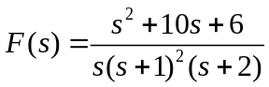

Evaluate f(0) and f() if they exist.

Solution

f(0) = 0
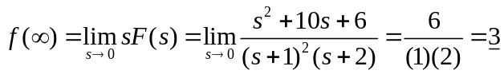= 3

